Track Spot Light

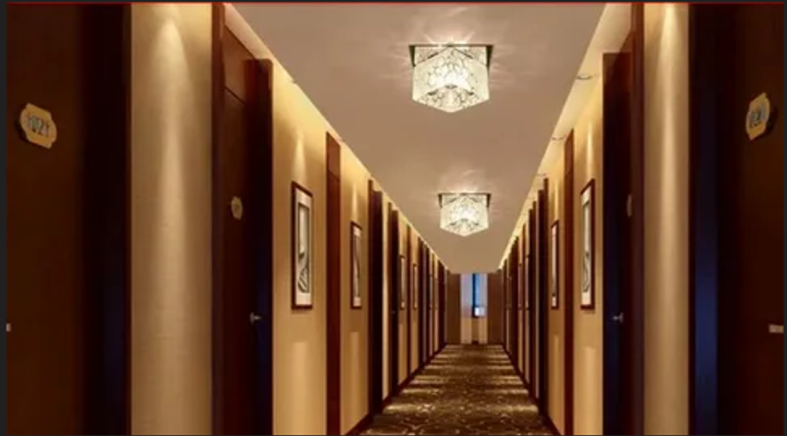

#### ****Description:****

**Track Spot Lights** are versatile, energy-efficient lighting solutions designed to provide focused and directional light for track lighting systems. These lights are perfect for highlighting specific areas or objects, such as artwork, retail displays, or architectural features. With adjustable heads and a sleek design, Track Spot Lights offer both functionality and style.

* **Technology:** LED.
* **Compatibility:** Standard track lighting systems (H, J, or L track).
* **Bulb Type:** Integrated LED (non-replaceable).
* **Wattage:** 10W (equivalent to 75W incandescent), 15W (equivalent to 100W incandescent).
* **Lumens:** 800 lumens (10W), 1200 lumens (15W).
* **Color Temperature:** 2700K (warm white), 3000K (soft white), 4000K (cool white).
* **Dimmable:** Yes (select models).
* **Lifespan:** 50,000 hours.
* **Energy Efficiency:** Energy Star certified.
* **Beam Angle:** Adjustable (typically 15° to 60°).

#### ****Key Features:****

* **Adjustable Heads:** Allows you to direct light precisely where it’s needed.
* **Energy-Efficient:** Uses up to 85% less energy than traditional incandescent bulbs.
* **Focused Lighting:** Ideal for highlighting artwork, retail displays, or architectural features.
* **Dimmable Options:** Available in dimmable models for adjustable brightness.
* **Long Lifespan:** Lasts up to 50,000 hours, reducing the need for frequent replacements.
* **Sleek Design:** Modern and compact, suitable for both residential and commercial use.
* **Easy Installation:** Compatible with standard track lighting systems.

#### ****Pricing:****

* **Single Track Spotlight (10W):** $29.99
* **Single Track Spotlight (15W):** $39.99
* **4-Pack (10W):** 99.99(99.99(25.00 per light)
* **4-Pack (15W):** 139.99(139.99(35.00 per light)

#### ****Where to Use:****

* **Art Galleries:** Highlight artwork with precise, focused lighting.
* **Retail Stores:** Showcase products with bright, adjustable spotlights.
* **Living Rooms:** Accentuate decor or architectural features.
* **Kitchens:** Provide task lighting for countertops and workspaces.
* **Offices:** Enhance productivity with bright, adjustable light.

### ****Customer Reviews:****

* ⭐⭐⭐⭐⭐ "These Track Spot Lights are amazing! They provide bright, focused light, and the adjustable heads make it easy to direct the light exactly where I need it." – Sarah L.
* ⭐⭐⭐⭐ "Great value for the price. The lights are bright, and the dimming feature is smooth and reliable. Highly recommend for anyone looking to upgrade their lighting." – James T.
* ⭐⭐⭐⭐⭐ "I love how energy-efficient these spotlights are. The sleek design blends perfectly with my modern decor." – Emily R.

### ****How to Order:****

1. Visit our website: [www.brightworldlighting.com](http://www.brightworldlighting.com/)
2. Select your preferred spotlight type and pack size (Single or 4-Pack).
3. Add to cart and proceed to checkout.
4. Enjoy free shipping on all orders over $100!

### ****Warranty and Support:****

* **Warranty:** 2-year limited warranty covering manufacturing defects.
* **Customer Support:** Contact us at [support@brightworldlighting.com](mailto:support@brightworldlighting.com) or call +1-800-123-4567 for assistance.

### ****Visual Representation:****

Include high-quality images of the Track Spot Lights in different settings (e.g., art gallery, retail store) to showcase their versatility and design.